Neural Network Model Report

**Overview**

The purpose of this analysis was to make calculations based on data provided by a fictional non-profit foundation called Alphabet Soup. I was tasked to predict whether applicants for their funding would be successful based on the use of machine learning and neural networking.

**Results (from bulleted questions in the assignment)**

1. 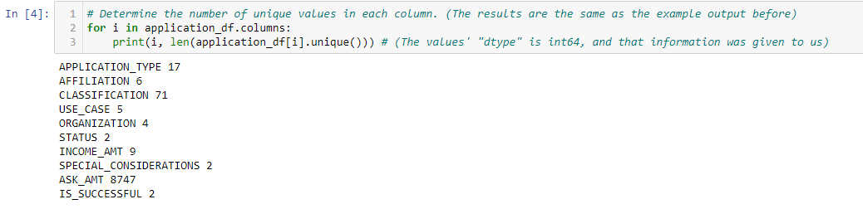I considered the targets for the model were the unique values that were calculated in the dataset.
2. 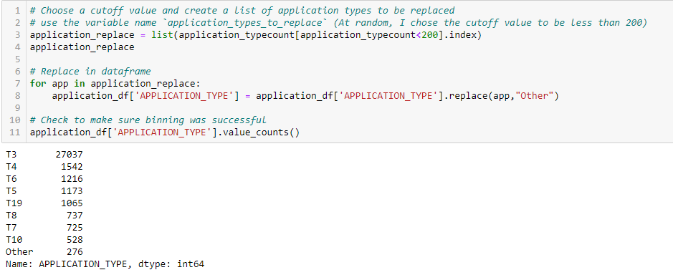The variables that I considered to be features were the values that were used to prep the data for its calculations, this being the “CLASSIFICATION”, “APPLICATION_TYPE” and “IS_SUCCESSFUL” columns (even though the last one was removed immediately afterwards).
3. 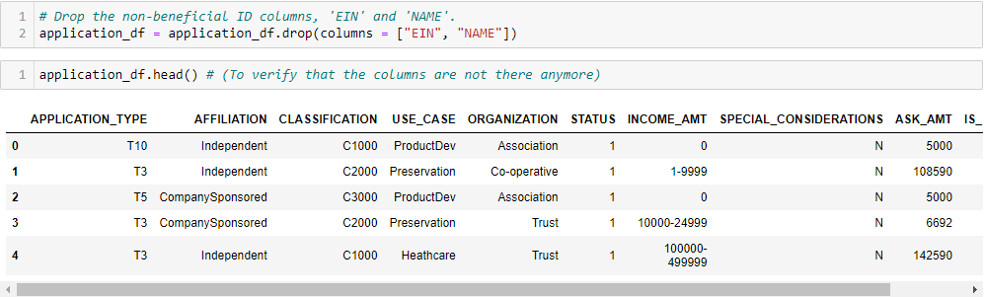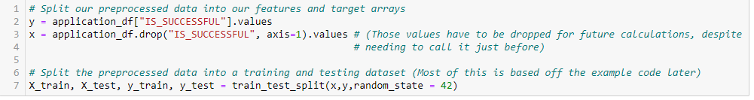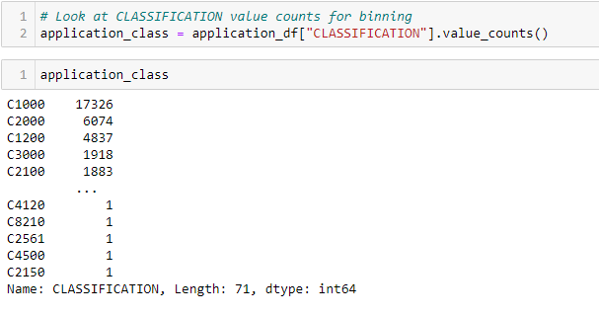While this is mostly based on the fact that the homework directions told me to remove it, the variables that were neither targets nor features was the “EIN” and “NAME” columns and were removed shortly into the assignment.
4. For the first attempt (in the Starter Code file), I went with three hidden layers, the default number of neurons (which was done in class), and went with a mix of both “relu” and “sigmoid” activation functions.
5. 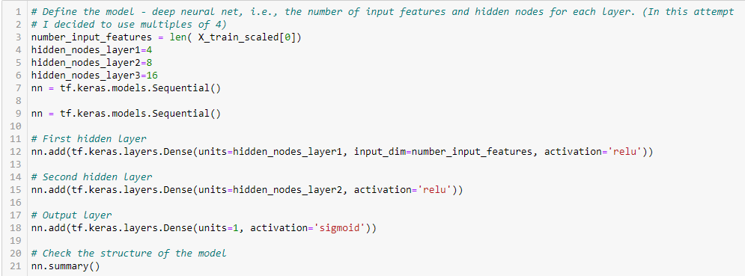I was unable to reach the target model performance, despite my later optimization attempts.
6. 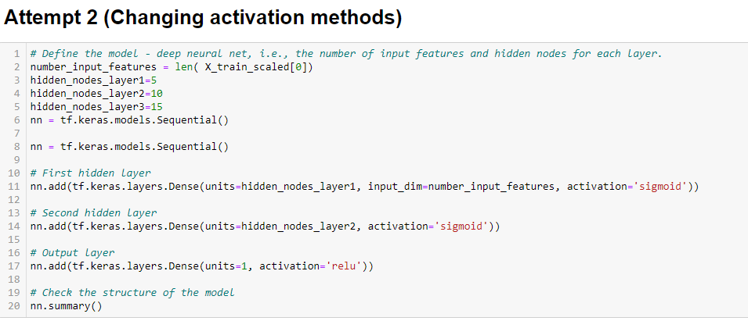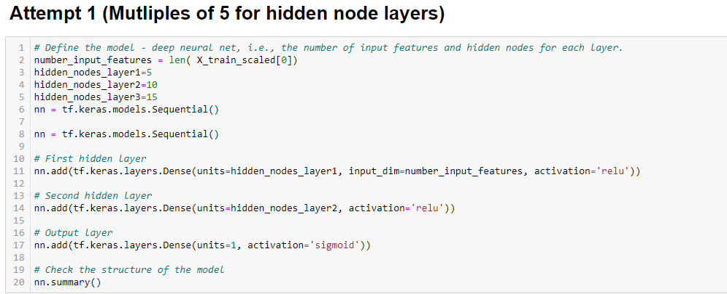In my attempts to reach the target model, I went and changed the multiples used, the activation functions, and finally used a mix of the former two but adding more layers.

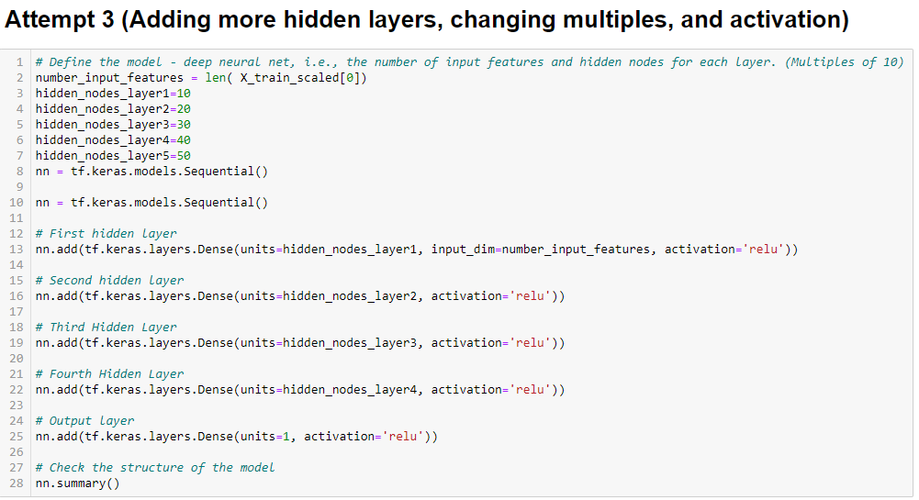**Summary**

Based on the results of this deep learning model, I found that regardless of my changes to the calculations in an attempt to reach the desired target range, I could not do so. I would probably recommend using a different model (such as Linear Regression or Random Sampling) as allowing more of a random factor to the results may help with a more accurate form of data if it is trying to predict future events. In my opinion, the data is somewhat static, and changing around how the numbers are organized doesn’t change the data itself, which to me is why despite my better efforts the accuracy factor remained pretty much the same.